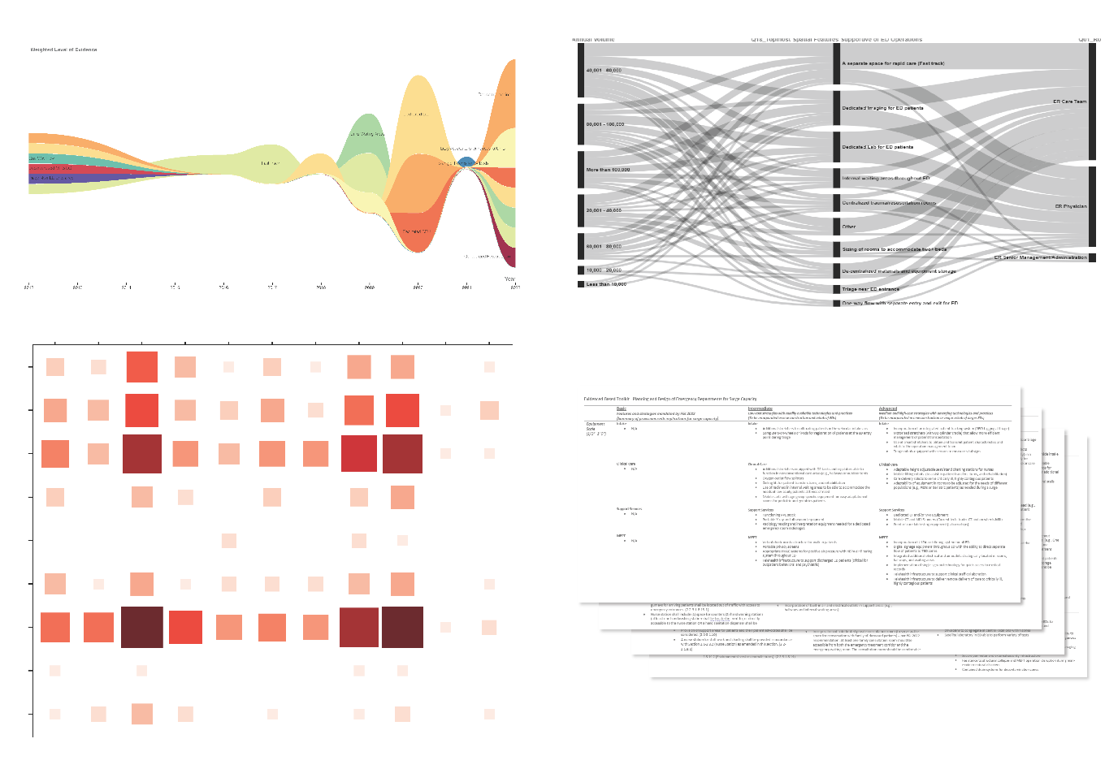
Ali Momen-Heravi 2022-2023: Toward Emergency Department Resiliency: Design and Planning for Surge Capacity
Background: Over the past decade, Emergency Departments (EDs) across the United States experienced more frequent and severe surge events. The combined effect of sudden increases in patient visits, limited resources, potential access blocks, and risks to the infrastructure and staff of EDs during surge events can decrease care delivery performance, negatively impacting the nation's healthcare outcomes. Problem Statement: While healthcare operation professionals have started to optimize the emergency department’s operational response to surge events, there is a lack of practical knowledge about the role and potential of the built environment in enhancing the emergency department’s response to overcrowding incidents. Methods: This study utilized a systematic literature review of peer-reviewed journal articles published between 2012 and 2022 to identify spatial design strategies that enhance surge capacity within the emergency department. In addition, this study used survey and interview research strategies to capture the perspective of emergency department clinicians and senior management staff nationwide on spatial interventions that enhance surge capacity. Results: The systematic literature review revealed several innovative spatial design features at multiple levels of the environment support clinical workflows, helping to address surge events more effectively. The survey and interview results indicated that certain environmental design strategies may perform better in some specific contexts. Also, the literature reviews and interviews with clinicians revealed several spatial need changes due to emerging technologies and best practices. Conclusions: This study provided fresh insights into how emergency department spaces can be designed to address surge events and highlighted emerging trends and best practices to enhance surge capacity. The findings from this study were used to create an evidence-based design toolkit that helps healthcare professionals and stakeholders plan and design more resilient emergency departments.

